Code Signing Standard
  - Cryptographic Governance Framework
Version 1.0

Preface 3
Purpose 3
Scope 3
Intended Audience 3
Terminology 3
References 3
Introduction 4
Applicable Security Principles 4
Code Signing Functional Model 5
Flow 5
Roles & Responsibilities 6
Certificate Management 6
Time Stamping 7
Trust Anchors 7
Key Management 8
Glossary 9

Preface

Purpose
The objective of this document is to identify security requirements that should be adhered to in the implementation and management of a code signing process.

Scope
The scope of this document is to provide a set of high-level security requirements for the protection of application software during deployment, using code signing techniques.

Intended Audience
The audience for this document include internal project teams, developers, and security engineers.

Terminology
For the purposes of this overall document, the following definitions apply:
- The terms "must" identify mandatory statements;
- The term "strongly recommended" identifies a recommendation, which should be followed, but can be exempted provided that such an exemption is recorded and accepted;
- The term "should" identifies a recommendation, which should be followed as best practice;
- The terms "may" or "can" identify options.

References
- Cryptographic Key Management Standard
- RFC 3161 Internet X.509 Public Key Infrastructure Time-Stamp Protocol (TSP)
- RFC 5816 ESSCertIDv2 Update for RFC 3161
- RFC 3628 Policy Requirements for Time-Stamping Authorities (TSAs)
- ANSI ASC X9.95 Standard for Trusted Time Stamps
- ETSI EN 319 422 Electronic Signatures and Infrastructures (ESI); Time-stamping protocol and time-stamp token profiles
- ETSI TR 119 100 Electronic Signatures and Infrastructures (ESI); Guidance on the use of standards for signature creation and validation
- CA/Browser Forum Code Signing Baseline Requirements

Introduction
Trusted IT systems processing data, such as payment, are based on a general client-server architecture, and for some projects the client application code developed must be distributed to clients. Threats exist that an attacker could modify application code executing on the client’s system and in so doing be able to perform an unauthorized action, which could involve the illegal transfer or modification of data. Where this code is developed by in-house, appropriate actions must be taken to secure this code.

The application code must be able to be distributed by unsecured means, but the user/executor of this code must be able to verify the authenticity of the code, confirming that it is authorized, and hence have trust in the code, and be able to verify its integrity.

The technology developed to perform this security service is known as code signing. Code signing is a mechanism whereby publishers of software and content can use a certificate-based digital signature to verify the origin and integrity of the code, thus allowing users to decide whether or not to install it based on a level of trust from the publisher. Making use of digital signatures the code to be protected is signed by a private key under the control of the code issuing authority. On receipt, the user can verify the authenticity and integrity of the code by verifying the signature.

There are two code signing standards that must be supported
- Sun Java code signing technology
- Microsoft Authenticode code signing.

Each methodology has its own set of tools and differences in their implementation, they are not interoperable.

Applicable Security Principles
Defence-in-depth: Security controls will be defined for the physical, network, host and application layers.
- Least privilege: An end user or process will be given just enough rights needed to perform their activity.
- Default deny: Access and/or privileges will be denied unless specifically authorized.
- Role separation: privileges shall be defined such that it requires collusion to perform an act which can lead to a fraudulent transaction within the production environment.

Code Signing Functional Model

Flow
The assumed systems model and flow for generating code, signing it and delivery is shown below:
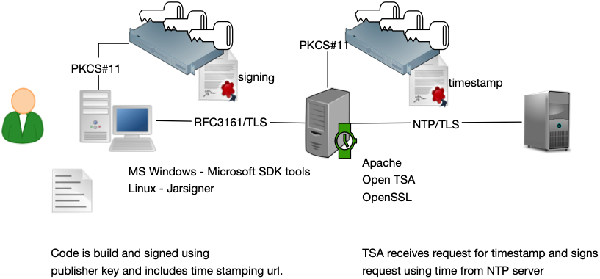

- Local Time Stamp Authority avoids additional Trust Anchors if the application will only be executed on internal network.
- Professional Time Stamping Authority requires the publisher to purchase certificates from the TSA.

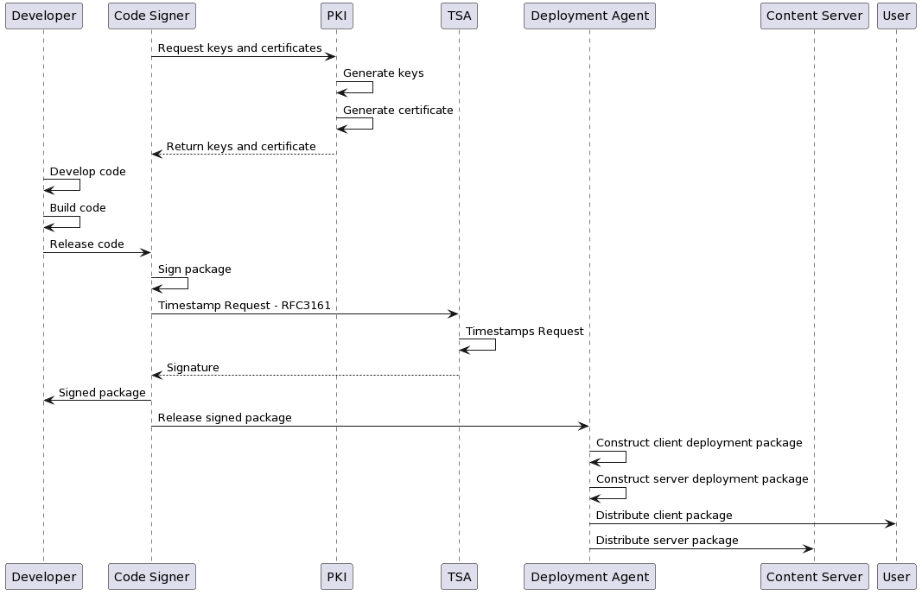

Roles & Responsibilities
The following roles are defined:
- Developer - an individual who develops and builds a business application.
- PKI - The Public Key Infrastructure (PKI) systems and processes to manage keys and trust on which code signing relies.
- Code Signer - an individual or group authorized to request code signing certificates and sign code.
- Deployment Agent - an individual or group authorized to deploy the application to production environments.
- User - an individual or organization who will execute the released code.
Code signing should be performed by staff not directly involved in the development of code; developers should not perform code signing. This separation or duties in in line with best practice and facilitates:
- Good release management, developers are subject to significant pressure to release code within schedule that may encourage them to bypass due process
- Configuration Control and Management of source code. The separation of the build and sign capably from development encourages good practice such as independent code review or source code release management.

Capability of code signing of production code must be restricted to staff, who must not be directly involved in the development of that code.

The final assembly and packaging of code for release, as performed by the Code Signer is the single point in time when the complete package is combined and should be in accordance with approved process. This is the most appropriate time when the code package should be signed.

Code Signers must perform the code signing operation within the 'build process’.

To ensure only authorized code is signed, and that the code has been properly processed prior to signing the signature key must be under the control of approved entities.

Any code that is submitted for signing should be strongly authenticated before it is signed and released.
All code signing activities must be logged for auditing and/or incident-response purposes.

Certificate Management
Prior to execution at ‘run-time’, signed code is validated to ensure its integrity. Should this validation fail, the code will not be executed. Failures may be due to unauthorized modification of the code but may also be due to expired certificates. Since code signing certificates typically have a 1-to-2-year lifetime it is possible that the certificate may expire within the lifetime of the application.
While this can be addressed by re-signing the code prior to expiry, this would assume that the code is downloaded each time, prior to execution or distributed again to all users. Code previously installed or to be installed from old media may fail.

Proper key and certificate management processes must be defined, in accordance with [1].
A separate test code signing infrastructure, including separate certificates, to test-sign pre-release builds of software must be established.

Time Stamping
Time stamping is the addition of a trusted time to a data object in a manner that it cannot be altered without detection. The addition of timestamps to 'signed code objects' allows the verification process to determine if the code signature was valid at the time it was generated, as opposed to the time it was verified.
This has significant advantages in addressing the issues described above. However it has the disadvantage of disabling the alert that would inform users that the certificate has expired and any capability to revoke code by CRL or otherwise.
It is reasonable to assume that code developed will have bugs discovered over time, which present a security risk. The capability to preclude the execution of this 'obsolete code' would be desirable. By having certificates expire after a defined time, would facilitate automatic self-revocation of code. ensuring that only up to date code is used.

If "time stamping" is used, it must be generated using trusted systems and should be in compliance with open standards.
If "time stamping" is used, a process should be approved for communicating or enforcing minimum code version usage in the event of a security vulnerability.

Trust Anchors
Signature verification of the code signing certificates should be validated up to the point of a trust anchor (Root CA).
Initial installation of code could be used to install the trust anchors; however this would not provide an independent means to verify the trust in the code since the code could have been signed with an unauthorized key, whose certificate is issued from an authorized CA, which could be included within the package. The trust anchor should therefore be obtained using a means independent of the code distribution.

Trust anchors should not be distributed within the same package as the signed code.
Test certificates must chain to a completely different root certificate than the root certificate that is used to sign publicly released products; this precaution helps ensure that test certificates are trusted only within the intended test environment.
Code verification must be capable of validating signatures within a multilayer PKI.
Internal corporate PKI should be selected to provide a code-signing certificate for code to be executed only within internal infrastructure. This provides more granularity of policy control and key management.
The choice of which PKI to use is based on the scope of both the code signer and all users of the code. Ideally the selected PKI should have its trust anchor already installed within the target operating platforms and should have issuing policies compatible with the intended use.

Key Management
Unauthorized access to an approved code signing key presents the risk that unauthorized code may be approved, signed and introduced into production systems, resulting or facilitating a fraudulent action.
Holding specific individuals to account as opposed to a shared functional use of the signing key is preferred. There may be many approved certificates in use and code need only be signed by one of the sets of approved keys to be valid.

Signing keys must be protected such that they can only be used by authorized individuals.
Mechanisms must be deployed to identify the employee who signed code. (Individual certificates could be issued to each authorized user, certificates should be anonymized).
Production signing keys must not be used for non-production code
Code signing keys must be stored and used from within approved hardware devices (Smartcard or HSM), where practicable, application access to these devices should be in compliance with industry standard interfaces (PKCS#11).

Glossary
PKCS#11 | PKCS#11 is one of the Public-Key Cryptography Standards, and also refers to the programming interface to create and manipulate cryptographic tokens (a token where the secret is a cryptographic key).
TSA | Time Stamping Authority
HSM | Hardware Security Module, a physical computing device that safeguards and manages cryptographic keys, performs encryption and decryption functions for digital signatures, strong authentication and other cryptographic functions.

